Fuctional Bugs

1.Summary: Items added to the cart are displayed after the user is logged out..

1.Logging in an existing user
2.Selecting an album
3.Then adding the album using the “Add to cart” button
4.The user is redirected to the cart page
5.After the user is logged out the number of the items that were added to the cart and the cart are still visible.
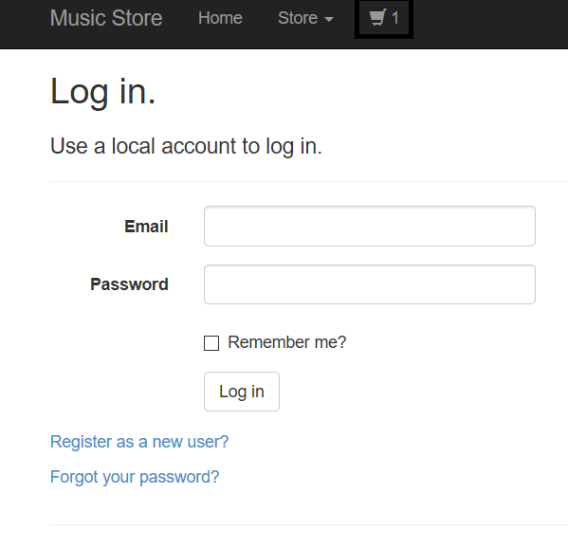
Expected result: The user to be redirected to the login page.
Actual result: The number of the items that were added to the cart and the cart are still visible.

2. Summary: Successful order without any items added to the cart

1.Logging in an existing user
2.Selecting an album
3.Then adding the album using the “Add to cart” button
4.The user is redirected to the cart page
5.Then the item was removed
6.Then clicked on the checkout link from the Cart Page
7.Although no items were added to the cart the user is redirected to the shipping information page where after filling the required fields appropriately the user was redirected to the successful order page

Expected result: The user to be redirected to the store page.
Actual result: The user is redirected to the shipping information page where after filling the required fields appropriately the user was redirected to the successful order page

3. Summary: Purchase can not be initialized without entering the Promo code

1.Logging in an existing user
2.Selecting an album
3.Then adding the album using the “Add to cart” button
4.The user is redirected to the cart page
5.Then clicked on the checkout link from the Cart Page
6.Then the user is redirected to the shipping information
7. After entering all the shipping info if the promo code is not used the purchase can not be initialised it redirects to the same link

Expected result: After filling the required fields appropriately the user to be redirected to the successful order page
.Actual result: After entering all the shipping info if the promo code is not used the purchase can not be initialised it redirects to the same link

4. Summary: Promo code is not case sensitive.

1.Logging in an existing user
2.Selecting an album
3.Then adding the album using the “Add to cart” button
4.The user is redirected to the cart page
5.Then clicked on the checkout link from the Cart Page
6.Then the user is redirected to the shipping information
7. After entering all the shipping info the checkout could be completed with the promo code entered with lower case instead of upper
Expected result: A message that informs the user that the promo code is incorrect.
.Actual result: Checkout is Completed when the promo code entered with lower case instead of upper.

